
- INTRODUCTION/SOURCES OF LAW
  - In General
    - A contract is a promise or set of promises, for the breach of which the law gives a remedy, or the performance of which the law in some way recognizes as a duty.
      - Elements for Agreement for Exchange:
        - Exchange of Money for goods or services;
        - Immediate, or spread out over time;
        - Legal mechanism for protecting expectations
    - Always Ask Yourself:
      - What Body of Law will govern this contract?
        - Are we dealing with goods or services?
          - (Moveable) Goods – Apply the UCC
          - Services – Apply Common Law/Restatement
      - Predominate Factor Test – Consider the following:
        - Language of the contract;
        - Nature of the business of the supplier; and
        - Intrinsic worth of the material.
    - Formation [Of a Contract]
      - Restatement (Second) § 17: Formation of a contract requires a bargain in which there is a manifestation of mutual assent to the exchange and a consideration
        - A contract can be formed without “bargaining” of the process of going back and forth between offer and acceptance to reach a deal
  - The Uniform Commercial Code (UCC)
    - UCC governs the sales of moveable goods; UCC § 2-102; § 2-105(1)
      - Under UCC §2-204, a contract for sales of goods may be made in any manner sufficient to show agreement, including conduct by both parties which recognizes the existence of such a contract
    - UCC governs the sales of all moveable goods, not only the ones between merchants
      - UCC §2-104(1) – a merchant is defined as one who regularly deals in goods of the kind sold or who otherwise by his occupation holds himself out as having knowledge or skill peculiar to the practices or goods involved
    - if a contract involves both the sale of goods and services, the predominate test will be used [above]
    - UCC § 1-103 (b) where the common law rules are not displaced by the UCC, common law/restatement rules will supplement the UCC and fill in the gaps
  - The Common Law of Contracts/Restatement
    - Contracts that do not involve the sales of goods are governed by the common law/restatement, and frequently include: service contracts, contracts involving real property, and assignment of legal claims
  - Basic Definitions and Concepts of Contract Law/Types of Contracts
    - Contractual Obligations[As to Formation]:
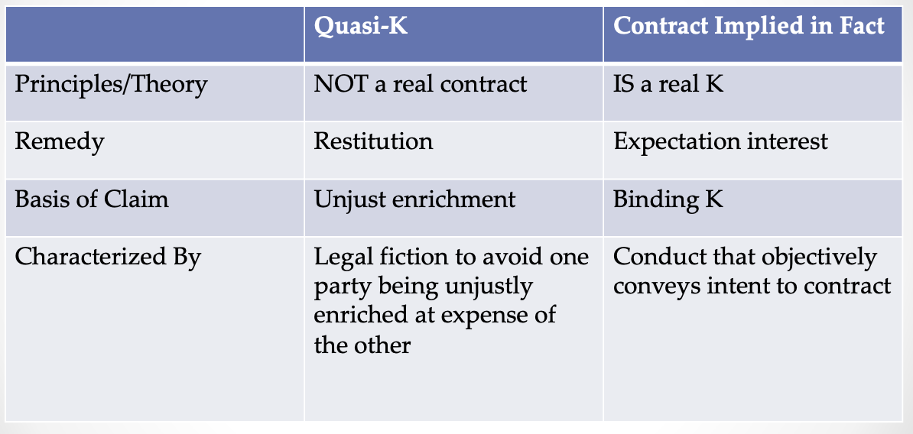
      - Express
        - Formed by language, oral or written
      - Implied-in-Fact
        - Formed by manifestations of assent other than language, ie by conduct
      - Implied-in-Law [Quasi-Contract]
        - Not contracts at all, but is a remedy available to avoid unjust enrichment
          - Usually happens with emergency services or where merchants return extra change to the buyer
- CONTRACT FORMATION: OFFER AND ACCEPTANCE [MUTUAL ASSENT]
  - In General
    - Mutual Assent is often said to be an agreement on the same bargain at the same time – a meeting of the minds
      - Courts use an objective measure by which each party is bound to the apparent intention that he manifested to the other
  - The Offer
    - Requirements of an offer R2d § 24
      - Addressed to a specific offeree;
      - Reasonably certain terms; and
        - Definite and Certain terms [“REASONABLY CERTAIN TERMS”]
          - Basically, whether there is enough of the essential terms have been provided so that a contract including them would be capable of being enforced.
          - Typically include:
            - The identity of the offeree[“SPECIFIC OFFEREE”];
            - The subject matter; and
            - The price to be paid
        - Missing Terms
            - One or more terms that are left open do not prevent the formation of a contract if it appears the parties intended to make a contract and there is a reasonably certain basis for giving a remedy
      - Manifestation of willingness to be bound
Ads are generally not an offer (unless addressed to a specific offeree, like first come, first served)
Freely revocable by the offeror prior to the acceptance and if properly communicated (expect option contracts) – taking action inconsistent with keeping the offer open will revoke the offer only if the offeree learns about it from a reliable source
The offer will remain for the time stated or for a reasonable time [reasonable time will depend on the industry’s customs]
    - Definite and Certain terms [“REASONABLY CERTAIN TERMS”]
      - Basically, whether there is enough of the essential terms have been provided so that a contract including them would be capable of being enforced.
        - Typically include:
          - The identity of the offeree[“SPECIFIC OFFEREE”];
          - The subject matter; and
          - The price to be paid
    - Missing Terms
      - One or more terms that are left open do not prevent the formation of a contract if it appears the parties intended to make a contract and there is a reasonably certain basis for giving a remedy.
    - Option Contracts
Option Contracts (CL) and Firm Offers (UCC)
Option Contracts | UCC § 2-205 Firm Offers
Elements (3) for an enforceable option contract:  - An offer;  - A subsidiary promise to keep the offer open; and  a sell-by date; the offer expires in 30 days  - a valid mechanism for securing enforcement of the subsidiary promise  giving consideration ie payment for the option or a promise of performance  R2d § 45 [UNILATERAL] : (1) Where an offer invites an offeree to accept by rendering performance and does not invite a promissory acceptance, an option contract is created when the offeree tenders or begins the invited performance or tenders a beginning of it (2) offeror’s duty of performance under any option contract so created is conditional on complete or tender of the invited performance in accordance with the terms of the offer.  R2d § 87 Option Contract  - An offer is binding as an option contract if it  - Is in writing and signed by the offeror, recites a purported consideration for the making of the offer, and proposed an exchange on fair terms within a reasonable time; or  - Is made irrevocable by statute  - An offer which the offeror should reasonably expect to induce action or forbearance of substantial character on the part of the offeree before acceptance and which does induce such action or forbearance is binding as an option contract to the extent necessary to avoid injustice  ___ Only evaluate acceptance AFTER determining that an option K made an offer irrevocable ____ | A merchant can make a firm offer (an irrevocable offer) to either buy or sell goods without consideration as long as:  - the offer is made by a merchant;  merchant in terms of special knowledge or skill with respect to the practices or goods involved in a transaction  - the offer is made in a writing signed by the merchant; and  - the offer expressly states by its terms that it will be held open  the option cannot be revoked during the time stated in writing, if no time is state then the option will be open for no longer than three months; anything longer than three months will need to be renewed and consideration must be present  after three months the offer will become irrevocable but still enforceable if there was no consideration or renewal offered.  __ UCC § 2-205 supplements common law possibilities, it does not replace them __

    - Termination of an offer
      - The power of acceptance created by an offer ends when the offer is terminated
        - Termination by Offeror – Revocation – must be done before acceptance
          - Methods of communications
            - Revocation by direction communication – offeror directly communicates termination of the offer to the offeree
            - Revocation by indirect communication – offer may be effectively terminated if the offeree indirectly receives: (1) correct. Information, (2) from a liable source, (3) of acts of the offeror that would indicate to a reasonable person that the offeror no longer wished to make the offer
          - Effective When Received
            - A revocation is generally effected when received by the offeree, this does not mean the revocation needs to be read by the offeree by that it simply comes into the possession of the person addressed,
        - Option Contracts/Firm Offers
          - Option Contracts – open for the time stated or reasonable time (in CL consideration is needed; in UCC consideration is needed after 3 months) See chart above.
        - Detrimental Reliance
          - Offeror could reasonably expect that the offeree would rely to her detriment on the offer, the offeree does so reply, the offer will be held irrevocable as an option contract for a reasonable length of time – limited to a situation in which the offeror would reasonably contemplate reliance by the offeree in using the offer before it is accepted.
        - Beginning Performance in Response to True [Unilateral Contract] Offer
          - An offer that is a true unilateral contract becomes irrevocable once performance has begun. A unilateral contract is not fully formed until the performance is completed, but reasonable time needs to be provided in order to complete such performance.
        - Beginning Performance in a [Bilateral Contract]
          - A bilateral contract may be formed at the start of the performance, therefore once the performance starts, revocation is impossible. NOTE – notice of state of the performance may be necessary
      - Termination by Offeree

        - Rejection
          - Expressed
          - A counteroffer is a rejection in Common Law –only–
        - Lapse of Time
    - Revocation (also above)
      - Ask yourself: Is the offer irrevocable?
        - Offers are irrevocable for traditional option contracts, Rd2 § 87, and UCC § 2-205. See Chart Above.
      - Has the offer been revoked?
        - Direct Revocation
        - Indirect Revocation R2d § 43
  - Acceptance under Common Law
    - General Requirements to constitute effective acceptance in Common Law:
      - Under the mirror image rule, the acceptance must mirror the terms of the offer; and
        - The mirror image rule is a “last shot rule” because whoever makes the last counteroffer has their terms accepted by conduct
      - The acceptance must be communicated to the offeror
    - Communicating Acceptance
      - The offeree must communicate acceptance in the particular means requested by the offeror – if such is absent, the offeree is free by any reasonable means of communication/transmission
        - The means used by the offeror;
        - The means customarily used in similar transactions; or
        - A means of communication that is equivalent in expeditiousness and reliability to the means used by the offeror.
    - Circumstances where the requirement that acceptance should be communicated to the offeror may not apply:
      - Acceptance by Silence
        - Rd2 §69: (a) where an offeree takes the benefit of offered services with a reasonable opportunity to reject them and reason to know that they were offered with the exception of compensation.;
(b) Where the offeror has stated or given the offeree reason to understand that assent may be manifested by silence or inaction, and the offeree in remaining silent and inactive intends to accept the offer.;

(c) Where because of previous dealings otherwise, it is reasonable that the offeree should notify the offeror if he does not intend to accept.
      - Acceptance by Performance
        - R2d § 32: In case of doubt an offer is interpreted as inviting the offeree to accept either by promising to perform what the offer requests or by rendering the performance, as the offeree chooses.
      - Acceptance by Mail or other correspondence
        - R2d §63 (a) Common Law Mailbox Rule:
          - Unless the offer provides otherwise, (a) an acceptance made in a manner and by a medium invited by an offer is operative and completes the manifestation of mutual assent as soon as put out of the offeree’s possession, without regard to whether it ever reaches the offeror..
          - Acceptance is effective when the acceptance is dispatched.
        - MAILBOX RULE AND OPTION CONTRACTS
          - R2d § 63(b) an acceptance of an irrevocable offer is effective only upon receipt
  - Acceptance and the UCC
    - Unless the language of the offer states otherwise, acceptance may be made in any manner and medium reasonable under the circumstances
    - UCC rejects CL’s mirror image rule – UCC recognizes a binding contract despite the presence of nonconforming acceptance in – [UCC §2-207 Battle of the Forms]
      - UCC §2-207 Battle of the Forms
        - General background information of UCC §2-207
          - Deals with parties offering and accepting a contract on preprinted forms – since the offeree’s acceptance contains terms that vary from the offeror’s offer, the offeree’s response is a nonconforming acceptance – UCC deals with this in two ways:
            - Rejects the CL mirror image rule and treats the nonconforming acceptance as binding and a legally effective acceptance.
            - Secondly, rejects CL’s last-shot rule for determining what terms will govern the contract
          - Unless the acceptance is expressly made conditional on assent to the additional or different terms, the nonconforming acceptance will become binding
        - Transaction Involving a Consumer
          - Nonconforming acceptance or conformation – when one party is a non-merchant, the additional and different terms are construed as proposals for addition to the contract, and thus not part of the contract unless the offeror expressly agrees to the additional terms [UCC §2-207(2)]
        - TRANSACTIONS WHERE BOTH PARTIES ARE MERCHANTS
          - Additional Terms [UCC §2-207(2)]
            - Additional terms become part of the contract unless:
              - The offer expressly limits acceptance to the terms of the offer;
EXAMPLE: “This order expressly limits acceptance to the terms stated herein”
              - The offeror objects to the additional terms within a reasonable time after receiving notice of them; or
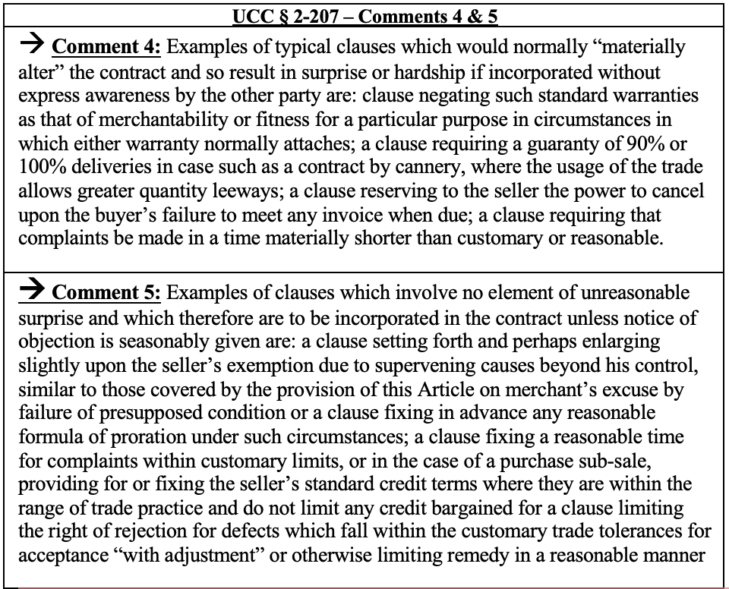
EXAMPLE: “We do not accept the binding arbitration clause provision set forth in your Acknowledgement of Order”
              - the additional terms would materially alter the contract
          - Materially Altering Terms
            - Terms that would result in surprise or hardship if incorporated without the express awareness of the other party
EXAMPLE of clauses that would MATERIALLY ALTER the contract:
                - A clause negating standard warranties, such as that of merchantability or fitness for a particular purpose in circumstances in which either warranty normally attaches;
                - A clause requiring that complaints be made in a time materially shorter than customary or reasonable; and
                - Any clause that would vary in a significant way an established usage of trade or a course of past dealing between the parties.

          - Different Terms – KNOCKOUT RULE
            - The majority of decisions employ the knockout rule and omit both the offeror’s original provision and the offeree’s differing provision from the resulting contract
EXAMPLE: Buyer’s purchase order contains a choice-of-law provision stating that CA law will govern disputes arising from the transaction, and the Seller’s order acknowledgment states that NY law will govern. Neither provision will be part of the parties’ contract; if the parties desire a choice of law provision, they will have to negotiate from scratch.
EXAMPLE: A crossed-out term is a different term
        - Conditional Acceptance under UCC § 2-207 (1)
          - The acceptance must expressly state that it is conditional on assent to the additional or different terms in order to be rendered as a [conditional acceptance].
            - If this is the case, no contract has been formed until the offeror expressly assents to the additional or different terms
          - What Constitutes a Conditional Acceptance under UCC § 2-207
            - The language of the [conditional acceptance] must be clear and conspicuous
EXAMPLE: Buyer sends Seller a purchase order for 1,000 widgets at the advertised price of $10 each. Seller sends Buyer an Acknowledgment of Order form that promises delivery of the widgets at the stated price but also contains boilerplate language negating warranties and limiting remedies in the event of a breach. Seller’s form also contains the following language in large bold font: “Our acceptance of your order is expressly conditional on your assent to the additional or different terms that appear in this acknowledgment.” Under the majority rule, the seller’s form constitutes a conditional acceptance of the Buyer’s order and thus does not operate as a legally effective acceptance. Thus, the exchange of forms does not create a contract. Either party is free to back out of the deal prior to the buyer’s assent to the additional or different terms.
- CONSIDERATION AND IN THE ABSENCE OF CONSIDERATION
  - Consideration and Bargain
    - Consideration In General
      - Elements of Consideration:
        - There must be a bargained-for exchange between the parties; and
        - That which is bargained for must be considered a legal value or, it must constitute a benefit to the promisor OR a detriment to the promisee.
      - Insufficient Consideration:
        - A promisor defending against an attempt to enforce a gratuitous promise can state his defense in several ways:
          - The promise is not supported by consideration;
          - There is a want of consideration, or consideration is lacking; or
          - There is legally insufficient consideration.
      - Failure of consideration:
        - A failure of consideration is a claim that the party has not performed in accordance with his promise
      - The preexisting duty rule:
        - A promisor cannot provide consideration where that consideration is a duty the promisor is already obligated to perform – preexisting duty rule – not consideration because the promisor must already perform that duty on the basis of the original contract
    - Bargained-For Consideration
      - R2d § 71 Requirement of Exchange; Types of Exchange
(1) to constitute consideration, a performance or a return promise must be bargained for.
(2) a performance or return promise is bargained for if it is sought by the promisor in exchange for his promise & and is given by the promise in exchange for that promise.
(3) The performance may consist of (a) an act other than a promise, or (b) a forbearance, or (c)the creation, modification, or destruction of a legal relation;
(4) performance or return promise may be given to the promisor or to some other person. It may be given by the promise or by some other person
        - Bargained-For Exchange: requires that the promise induce the detriment and the detriment induce the promise
        - Economic Benefit is not required - ie a parent telling their child that they will give them $1,000 to stop smoking – assuming the promise is not already legally obligated to perform the requested act
    - Inadequacy of Consideration
      - Assumes that there is consideration but argues that it is too small in comparison with the value of the promise for which it is exchanges
        - Sham consideration is not consideration – a mere pretense of bargain does not suffice, as where there is false recital of consideration merely nominal.
        - Token Consideration is not consideration – something entirely devoid of value
    - Illusory Promises
      - A promise to perform that leaves performance to the discretion of the promising party is an illusory promise and won’t constitute consideration.
        - Agreements that lack mutuality on one end.
        - “words in promissory form that promise nothing; they do not purport to put any limitation on the freedom of the alleged promisor, but leave his future action subject to his own future will, just as it would have been had he said no words at all…A prediction of future willingness is not an expression of present willingness and is not a promise.”

    - Bargain
      - Bargain requirement refers to the presence(or absence) of an exchange between the parties, not the process of reaching the deal.
        - Merely indicates an exchange, which could be beneficial or detrimental
    - Gratuitous Promises
      - Gratuitous promises are generally unenforceable under the consideration doctrine
      - Bargains Distinguished
        - Certain considerations determine whether an exchange is a bargain or a gratuitous promise
          - Distinguishing consideration from a condition on a gratuitous promise can be accomplished using three factors:
            - The language of the parties;
words suggesting benevolence rather than self-interest, such as gift
            - Commercial vs charitable or familiar context; and
bargains are standard operating procedures in a commercial context; versus gratuitous promises are made in family and charitable contexts more frequently
            - Benefit to the promisor
whether the promisor benefits from the performance
  - Alternatives in the Absence of Consideration to Enforce Contracts
    - Past or Moral Consideration [Restitution – also discussed below]
      - Generally, a promise given in exchange for something already given or already performed will not satisfy the bargain requirement, EXPECT WHEN:
        - R2d § 86 – Promise for Benefit Received
          - A promise made in recognition of a benefit previously received by the promisor from the promise is binding to the extent necessary to prevent injustice
          - A promise is not binding under subjection (1)

            - If the promisee conferred the benefit as a gift or for other reasons the promisor has not been unjustly enriched; or
            - To the extent that its value is disproportionate to the benefit
        - R2d § 86 – Promise for Benefit Received – in LAYMAN’S TERMS
          - Some jurisdictions, will enforce a promise made in recognition of a past benefit on the promisor and not on a third party; and
          - The benefit is material
EXAMPLE: A sees B is in grave danger and heroically intervenes to save the latter, injuring himself in the process. B gratefully promises to compensate A for his efforts. The court enforced the promise because A’s efforts bestowed a material benefit – the saving of life – on B. [Webb v. McGowin]
EXAMPLE: Good Samaritan bestowed the benefit of nursing services on the promisor’s son rather than on the promisor, the promise was not enforced. [Mills v. Wyman]
    - Promissory Estoppel
      - Doctrine: A promisee that reasonably relies to this detriment on a gratuitous promise may be able to enforce that promise – promissory estoppel – allows for the enforcement of certain promises even where there is no consideration in return
        - Requirements of promissory estoppel:
          - A promise;
          - Foreseeable reliance;
          - Actual reliance; and
          - Injustice without enforcement.
      - Elements of Promissory Estoppel – broken down –
        - A promise
          - There must be a promise on which the claim is based. The statement must contain an unambiguous assurance of future action to be considered a promise
        - Foreseeable reliance:
          - The promisee’s reliance must be reasonably foreseeable to the promisor at the time of the promise
        - Actual reliance
          - Actual reliance must be induced by the promise meaning action or reliance cannot be taken on account of the other factors
        - Injustice without enforcement
          - If all other three elements
      - Restatements
        - R2d § 90 Promise Reasonably Inducing Action or Forbearance
          - A promise which the promisor should reasonably expect to induce action or forbearance on the part of the promisee or a third person and which does induce such action or forbearance is binding if injustice can be avoided only by enforcement of the promise. The remedy granted for breach may be limited as justice requires
          - A charitable subscription or a marriage settlement is binding under subsection (1) without proof that the promise induced action or forbearance
      - Notes/Clarifying Points
        - PE is an independent theory of recovery where there is no contract
        - PE is a replacement for consideration in an option contract
    - Restitution
      - R3d of Restitution §1
        - A person who is unjustly enriched at the expense of another is subject to liability in restitution
      - R3d of Restitution §20
        - A person who performs, supplies, or obtains professional services required for the protection of another’s life or health is entitled to restitution from the other as necessary to protect unjust enrichment, if the circumstances justify the decision to intervene without request
        - Unjust enrichment under this section is measured by a reasonable charge for the services in question
      - R3d of Restitution §21
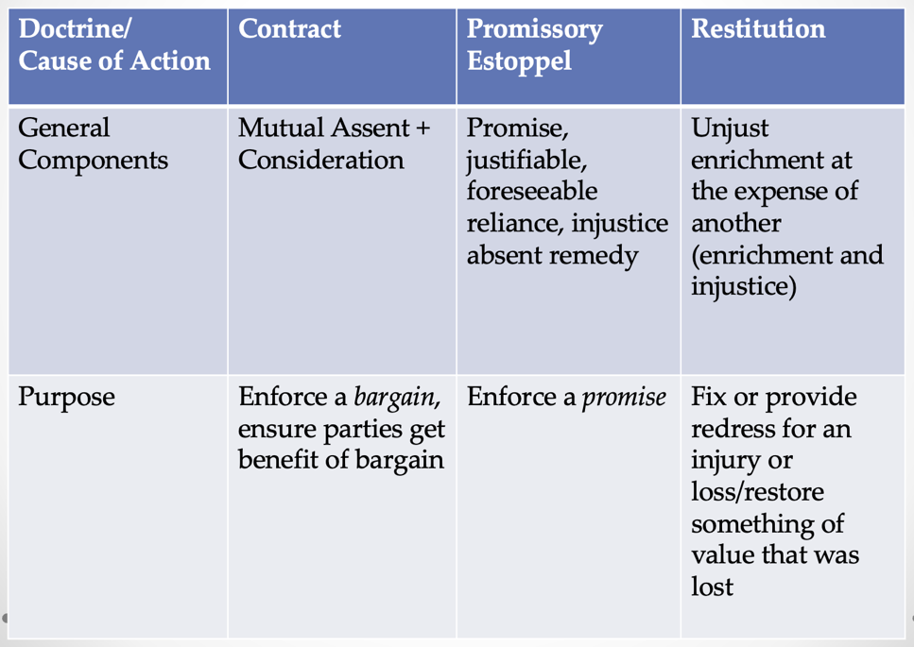
        - A person who takes effective action to protect another’s property from threatened harm is entitled to restitution from the other as necessary to prevent unjust enrichment, if the circumstances justify the decision to intervene without request, Unrequested intervention is justified only when it is reasonable to assume the owner would wish the action performed
        - Unjust enrichment under this section is measured by the loss avoided or by a reasonable charge for the services provided, whichever is less
        - Comment C: “there is no claim in restitution for services, however valuable, that the provider has rendered without an intent to charge.”
      - Promissory Restitution – Rd2 § 86 Promise for Benefit Received
        - Restatement says:
          - (1) a promise made in recognition of a benefit previously received by the promisor form the promise is binding to the extent necessary to prevent injustice.
          - (2) a promise is not binding under Subsection (1)
            - (a) if the promise conferred the benefit as a gift or for other reasons the promisor has not been unjustly enriched; or
            - (b) to the extent that its value is disproportionate to the benefit
        - Let’s Dumb it Down – Rd2 § 86 –
          - A benefit received by the promisor from the promisee;
          - A promise made in recognition of that benefit
          - Injustice if the promise is not enforced
        - KAP’s Notes
          - The promisor must be the one who directly benefited from the promisee’s action
- STATUTE OF FRAUDS
  - In General
    - R2d §110 Classes of Contracts Covered by Statute of Frauds
R2d §110 Classes of Contracts Covered by Statute of Frauds
R2d §110  (1) The following classes of contracts are subject to a statute, commonly called the Statute of Frauds, forbidding enforcement unless there is a written memorandum or an applicable exception:  - Contract of an executor or administrator to answer for a duty of his decedent(the executor-administrator provision);  - A contract to answer for the duty of another;  - A contract made upon consideration of marriage;  - A contract for the sale of an interest in land;  - A contract that is not to be performed within one year from the making thereof(one-year provision) | R2d §110  (2) The following classes of contracts . . . are now governed by the Statute of Frauds provisions of the UCC:  - A contract for the sale of goods for the price of $500 or more;  - A contract for the sale of securities;  - A Contract for the sale of personal property not otherwise covered, to the extent of enforcement by way of action or defense beyond $5,000 in an amount of value of remedy  (3) In addition, the UCC requires a writing signed by the debtor for an agreement which creates or provides for a security interest in personal property or fixtures not in the possession of the secured party.
Summary – Common Law Statute of Frauds  - Whether there is a contract or a promise within the statute of frauds?  - Contract or promise that cannot by its terms be fully performed within a year (but not lifetime contracts)  - Cannot be contractor promise for the transfer of an interest in land  - Whether there is a memorandum signed by the party to be charged that will satisfy the statute of frauds  - Does not have to be the contract itself  - Can be piece together from different writings if (1) the writings clearly refer to the same transaction and (2) the party to be charged has acquiesced in (not objected to) the unsigned one  - Writing must contain all the essential terms  - Must be signed by the party to be charged (could be initials, letterhead, or an email signature)  - Is there an exception that will take the contract out promise out of the statute of frauds and allow enforcement even without a memorandum?  - R2d § 139 – If the P relied on the contract or promise and just requires enforcement | Summary – UCC Statute of Frauds  - Whether the contract is within the UCC Statute of Frauds - $500 or more?  - Whether there is a memorandum signed by the party to be charged that satisfies the SOT?  - Must show that contract has been made, not just offered  - Must contain at least the quantity term  - Exceptions  - Merchant’s confirmation  - Specially manufactured goods  - Admission  - Part performance  - Reliance under R2d § 139 – If the P relied on the contract or promise and just requires enforcement

    - R2d § 139 Enforcement by Virtue of Action in Reliance (Consequences of Non-Compliance)
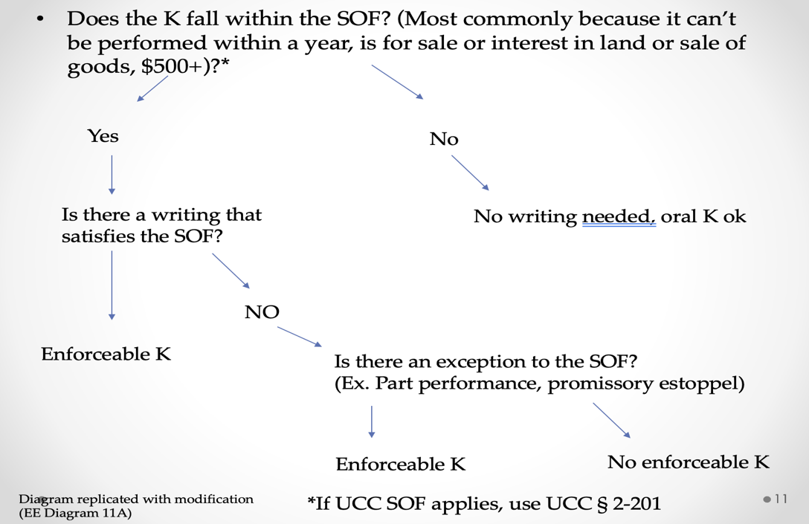
      - A promise which the promisor should reasonably expect to induce action or forbearance on the part of the promisee or a third person and which does induce the action or forbearance is enforceable notwithstanding the Statute of Frauds if injustice can be avoided only by enforcement of the promise. The remedy granted for breach is to be limited as justice requires.
      - In determining whether injustice can be avoided only by enforcement of the promise, the following circumstances are significant:
        - The availability and adequacy of other remedies, particularly cancellation and restitution;
        - The definite and substantial charter of the action or forbearance in relation to the remedy sought;
        - The extent to which the action or forbearance corroborates evidence of the making and terms of the promise, or the making and terms are otherwise established by clear and convincing evidence;
        - The reasonableness of the action or forbearance;
        - The extent to which the action or forbearance was foreseeable by the promisor.
      - Comments (a & b): §90 and this section are complementary to each other
    - Statute of Frauds is a defense of the formation of a contract
  - The Statute of Frauds in Operation
  - Evaluating Statute of Frauds Issues
  - Analyzing Problems under the Statute of Frauds
  - Analyzing Problems under the UCC Statute of Frauds
  - Effect if Satisfying the Statute of Frauds
  - No Mutuality if Obligation under the Statute of Frauds
  - Limitations of the Statute of Frauds

