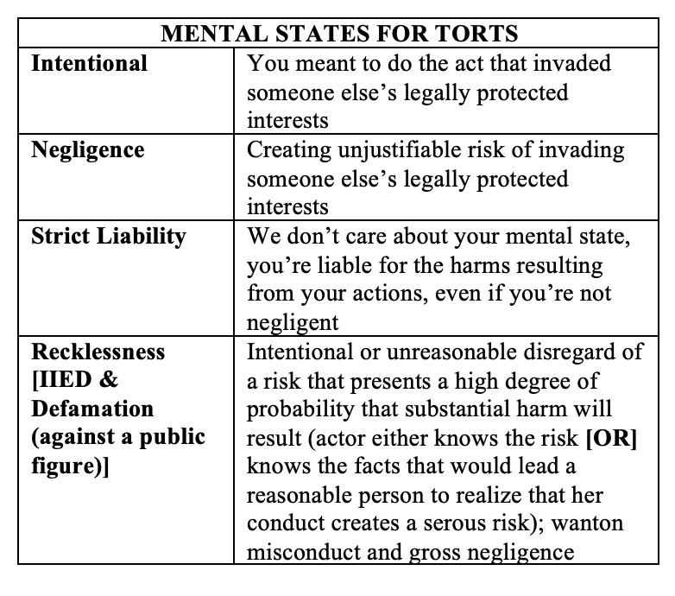
- INTENTIONAL TORTS
  - Elements of Intentional Torts
    - A voluntary act;
      - The act must be voluntary and not a product of pure reflex or if the D is unconscious when the act is performed
    - Intent
      - Intent – General and Specific [RULE STATEMENT]:
        - A person acts with the intent to produce a consequence if they act with either:
          - Specific Intent – the actor has the specific purpose to produce the consequence; or
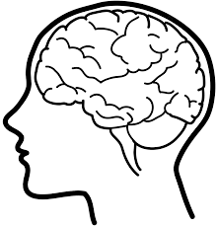
          - General Intent – the actor has knowledge with substantial certainty that the consequence would occur
      - Transferred Intent [RULE STATEMENT]:
        - Transferred intent applies in the following scenarios:
          - If the actor has intent to commit an intentional tort but instead commits another intentional tort, then the intent transfers; or
          - If the actor intends to commit an intentional tort against a person and instead commits the torts against another person, then the intent transfers
    - Causation;
      - As to intentional torts, the D’s act or a force set in motion by that cause the P’s injury
    - Harm; and
    - Lack of a privilege or defense
  - Battery
    - Elements:
      - Intentional
      - Contact, that is
      - Harmful or offensive
        - Restatement 19 – a bodily contact is offensive if it offends a reasonable sense of personal dignity
  - Assault
    - Elements – D must commit:
      - With intent either to
      - Cause a harmful/offensive act [OR] to cause an imminent apprehension of harmful/offensive contact
      - In which P is thereby put into such imminent apprehension of the harmful/offensive act
  - False Imprisonment
    - Elements:
      - D intends to confine;
        - It must be D’s purpose and
        - Substantial certainty in outcome
No liability for negligent or reckless conferment if the risk of harm is minimal
      - P is confined to a bounded area;
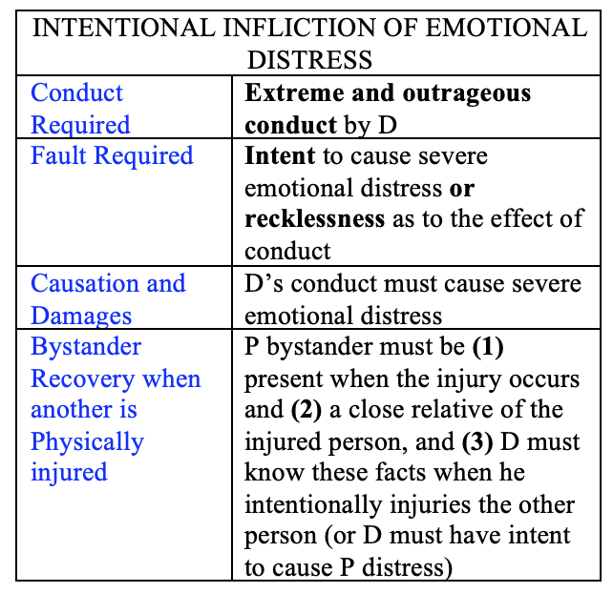
        - Being held in an enclosed area with no means of escape
        - Physical restraints on your person
        - Force or threat of force
        - False color of authority
        - Does not have to small area nor stationary
      - P is either (a) conscious of the confinement; or (b) otherwise harmed by it;
      - P does not consent to confinement;
      - Confinement not privileged by law
  - Intentional Infliction of Emotional Distress
    - Elements, D’s conduct must be:
      - Intentional or reckless;
      - So outrageous that is not tolerated by civilized society, and;
      - Result in serious mental injury to P
  - Trespass to Land
    - Elements, D must:
      - An intentional act that causes a physical invasion of the P’s land
  - Trespass to Chattels
      - If D does any of the following:
        - Dispossess the other of the chattel; or
        - Impairs the chattel as to its condition, quality, or value; or
        - Deprives the rightful possessor of the use of the chattel for a substantial time
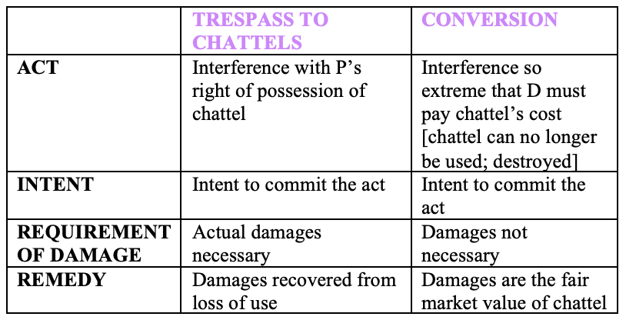
    - Definitions
      - Chattel: tangible personal property or intangible property that has a physical representation
      - Dispossession – direct interference with the P’s possession
        - Taking the property without the other’s consent
        - Obtaining the chattel through fraud or duress
        - Barring the other’s access to the chattel
        - Destroying the chattel while it is another’s possession (this usually leads to a claim for conversion, not trespass to chattel)
        - Wrongly taking the chattel into the custody of law (repossession lien, etc)
  - Conversion
    - Intentional act by D that causes the destruction of or serious and substantial interference with P’s chattel
  - DEFENSES AND PRIVILEGES TO INTENTIONAL TORTS
    - Privilege
      - Privilege may exist where:
        - The person affected consented to D’s conduct;
        - Public or private necessity; or
        - The defendant must act freely in order to perform an essential function. (i.e.: D looks out his window and sees P’s house on fire, D grabs his hose and goes over to the house, putting out the fire. D entry onto P’s land is privilege)
      - D has the burden of proof the existence of a privilege and that the privilege was exercised reasonably under the circumstances
    - Consent
      - Three types of consent:
        - Expressed consent – where the P affirmatively communicates permission for a D to act
        - Implied consent – under circumstances where a reasonable person would interpret the P’s conduct as evidencing permission to act
          - A little boy consented to play a dangerous game and was hurt, the consent was implied by his actions of chasing other boys with a rubber band [McQuiggan v. Boy Scouts of America]
        - Consent as a matter of law, where P is unable to consent:
          - Emergency action is necessary to prevent his death or serious injury;
          - A reasonable person would be expected to consent under the circumstances; and
          - No reason exists to believe that the P would not consent
      - Consent can be withdrawn, explicitly or inferred based on context and conduct
      - Consent has a scope – I consented to boxing, not getting shot.
    - Self-Defense
      - Must be proportional to:
        - The interest protected; and
        - The harm threatened.
    - Defense of Others
      - Must be proportional to:
        - The interest protected; and
        - The harm threatened.
        - Cannot be more than the force the person who is being defended could have used.
    - Defense of Property
      - Must be proportional:
        - Deadly force not typically allowed
    - Necessity
      - Private Necessity
        - A person has the privilege to enter another’s land and remain there, even without permission, to avoid greater harm to themselves or their property
        - P can still recover for this
      - Public Necessity
        - One can enter private property and even destroy it, to avert a public disaster, like a fire or flood
          - Catastrophic nature, affecting large groups of people – such as a neighborhood, city, etc
    - Authority
      - Shopkeeper’s Privilege
        - Statute: Detention and Search in Theft of Library Materials and Shoplifting
          - Imprisonment can be “privileged by law”
          - Allows temporary detention on one’s premises of a person reasonably suspected of tortuously taking goods – ie shoplifting
          - Duration and manner must be reasonable – only reasonable force may be used and only if necessary
      - Lawful Arrest
    - Defeating a Claim of Trespass:
      - Failure to establish a required element
        - Intentionally
        - Entering (or remaining on)
        - Someone else’s land
        - Without right or privilege
      - Affirmative defenses – public and private necessities
- NUISANCE
  - Types of Nuisances
    - Public Nuisance
      - Unreasonable interference with a right common to the general public – health, safety, or property rights of the community
      - [affects a broad group of people or the whole community]
      - Circumstances that may be an unreasonable interference with a public right:
        - Whether the conduct involves a significant interference with the public health, safety, peace, comfort, or convenience;
        - Whether the conduct is proscribed by a statute, ordinance, or administrative regulation; and
        - Whether the conduct is of a continuing nature or has produced a permanent or long-lasting effect, and as the actor knows or has reason to know, has a significant effect upon the public right
      - EXAMPLES – CASES
        - [Armory Park Neighborhood Association v. Episcopal Community Services in Arizona]
    - Private Nuisance
      - Thing or activity that substantially and unreasonably interferes with the P’s use and enjoyment of his land
        - The activity must be inconvenient or annoying to the average person of the community
      - [it specifically affects you regardless of it affects others]
      - Interferes must be unreasonable, meaning:
        - The gravity of the P’s harm outweighs the utility of the D’s conduct; or
        - If intentional, the harm caused by D’s conduct is substantial and the financial burden of compensating for this and other harms does not render unfeasible the continuation of the conduct
      - EXAMPLES – CASES
        - [Pestey v. Cushman]
  - Defenses
  - Remedies
- DEFAMATION
  - Elements:
    - D makes a false statement of fact
    - About P
    - To at least one third party
    - That is harmful to P’s reputation
    - D’s conduct was [at least negligent], meaning she/he did not take the care of an ordinary person would make before making the assertion
      - Standard [at least negligent] will depend on whether the P is a public figure or private citizen
  - – FURTHER BREAKDOWN OF ELEMENTS OR OTHER –
    - Defamatory Statement
      - What is it?
        - Allegation of fact,
        - That is untrue,
        - And reflects badly on your character in the community
        - In limited circumstances, an insinuation of fact can be defamatory
          - The average listener has a reason to believe I have knowledge of the factual matter and am communicating that fact through my insinuations
        - P must be identified/identifiable
        - Cannot defame the dead
      - What is not:
        - An opinion
        - Name-calling
        - Obvious hyperbole
    - Plaintiff/the party suing
      - The party suffering the defamation must have been a living person or an existing organization
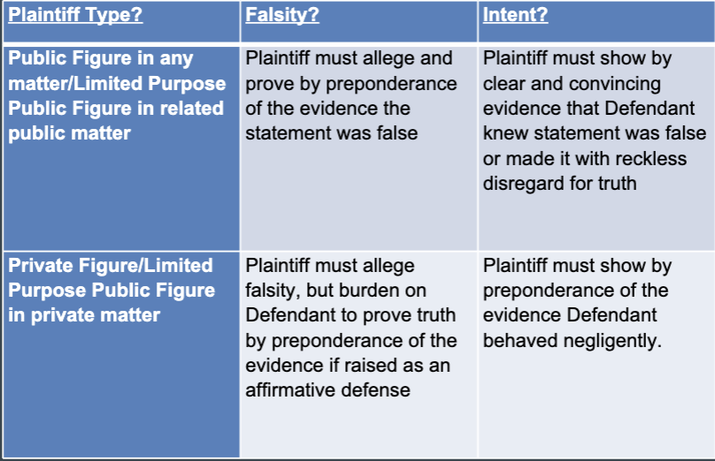
      - [Public Figure, Public Official, and Public Figure for Limited Purpose]
        - Public Figure:
          - Where a person has achieved such pervasive fame or notoriety that she/he becomes a public figure for all purposes and contexts (ie celebrities, the president of the US,
        - Public Officials:
          - Judge, politician, etc
        - Public Figure for Limited Purpose
          - Where a person voluntarily assumes a central role in a particular public controversy i.e.; prominent community activist, professor at a public law school, president of CAALA around CAALA members
    - Publication
      - Defined: merely means D told a third party
    - Reputational Harm
      - A statement is only defamatory if it is likely to diminish your standing in the community
    - Intent Requirement/Requirement
      - D must voluntarily and intentionally make the defamatory statement
        - Requisite statement of mind depends on (1) who the plaintiff is and (2) the subject matter
      - STANDARD of intent
        - Private citizen:
          - Negligence – meaning that D did not take the care a reasonable person would, to make sure what she/he was saying was true before saying it
        - Public Figure, Public Officials, and Public Figure for Limited Purpose
          - The defendant must have:
            - Knowledge that the statement is false; OR
            - Reckless disregard as to its truth or falsity
  - TWO TYPES OF DEFAMATION
    - LIBEL – injury/harm presumed by law – no need to prove damage
      - In print or other permanent media
        - Except in CA, which treats broadcasts (TV, radio, etc) as slander
      - All libel defamation is actionable without having to show harm – nominal damages
    - SLANDER
      - Per Quod – P needs to prove injury(harm) – not presumed
        - Any other defamatory statement said out loud to a third person and is able to identify who the statement is about
      - Per Se – subset of slander you can get nominal damages for – injury presumed – don’t need to prove
        - Calling someone dishonest in their business
        - Impugning the chastity of a woman
        - Saying someone has a vile or loathsome disease
        - Saying someone committed a crime of violence or dishonesty
    - CALIFORNIA PER SE v. CALIFORNIA PER QUOD
      - Both slander and libel need to go through the per se and per quod analysis
        - CA PER SE
          - Calling someone dishonest in their business
          - Impugning the chastity of a woman or a man or calling the person impotent
          - Saying someone has a vile or loathsome disease
          - Saying someone committed a crime of violence or dishonesty
          - Anything that is obviously, on its face defamatory without need to resort to outside information, inference, or innuendo (ie so-so does not believe the holocaust is real and everyone made it up; everything Alex Jones has ever said; anything Donald Trump has ever said)
        - CA PER QUOD
          - Everything else (ie statement that is defamatory because of the context or implied information, etc where the P is identifiable)
          - Requires proof of damages (regardless of whether its slander or libel]
  - Damages
    - Actual
      - Shame, humiliation, anxiety, loss of esteem in the community
      - Money spent rebuilding reputation
      - Lost of opportunities because of reputational damage
    - Nominal
      - The closest thing you’ll get to an apology – the court will award your nominal damages to vindicate your right
    - Punitive
      - For acts done with fraud, malice, or oppression
  - Common Law Defenses
    - Consent
      - Expressed or
      - implied
    - Truth
    - Privilege
      - Absolute
        - Spousal
        - Official Proceedings (Cal. Civil Code 47)
          - Statement in legislative proceedings
          - Statement in legal proceedings
      - Qualified
        - Common interest
          - Speaker and listener share a common concern
          - Requires good faith basis for statement
          - Limited to the subject matter of the common interest
- INVASION OF PRIVACY
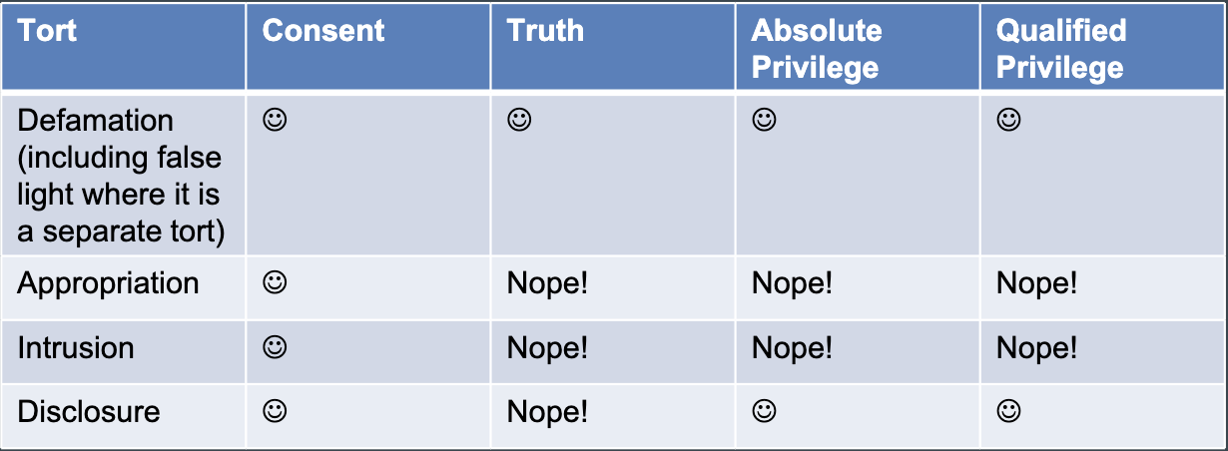
  - Appropriation
    - Elements:
      - D uses P’s name, image, or likeness
      - For a commercial purpose
      - Without P’s consent
    - Unauthorized use of P’s identity or likeness for the D’s commercial advantage
    - Newsworthiness exception
  - Intrusion
    - Elements:
      - D invades P’s seclusion
      - In a way that would be highly offensive
      - To a reasonable person
    - Invasion of privacy is present when D unreasonably intrudes into the P’s seclusion
      - [seclusion]: P’s right to physical solitude or to the privacy of personal affairs or concerns
  - Disclosure
    - Elements:
      - D spreads widely
      - Information of confidential nature
      - About P
      - That would be highly offensive to a reasonable person
    - Newsworthiness exception
    - Facts must be truly confidential. If it is stuff your friends and family know, it’s not confidential, even if your acquaintances don’t know it
- BUSINESS/ECONOMIC TORTS
  - What is a business tort?
    - Torts that arise from commercial relationships: contracts, business relationships, sales of goods or services, and sales of land
    - Breach of contract is not a business tort
  - Fraud
    - Elements:
      - Misrepresentations(false statement of fact, concealment, or non-disclosure)
      - Knowledge of falsity;
      - Intent to defraud;
      - Justifiable reliance; and
      - Resulting damage
    - Scienter is present when the D makes a misrepresentation knowing it to be false or recklessly possessing insufficient information as to its truth or falsity
      - First two elements form scienter
    - P must rely on the D’s misrepresentation, and such reliance must be justified – whether a reasonable person would have relied upon on it
    - Element of causation is met if a D’s misrepresentation played a substantial part in inducing the P to act as he did
    - [Damages]
      - There must be injury resulting from P’s reliance
        - Normally loss of money or property
    - Affirmative Defense
      - Innocent misrepresentation
        - If you honestly and reasonably believe something to be true, you are not liable for tort (either fraud or negligent misrepresentation)
  - Intentional Interference with Contractual Relations
    - Elements:
      - A valid contract between the P and a third party;
      - The D’s knowledge of this contract;
      - D’s intentional acts designed to induce a breach or disruption of the contractual relationship;
      - Actual breach or disruption of the contractual relationship; and
      - Resulting damage
    - – BREAKDOWN OF THE ELEMENTS –
      - Not limited to existing contracts
        - can also be for interference with probable future business relationships for which P has a reasonable expectation of financial benefit
      - Intent
        - D must know of the contract or business relationship, and must intent to interfere with contractual relations
      - Causation/Damages
        - Must be proved that the D’s act caused the breach in the contract and/or business relation causing P harm (ie of harm: non-performance, delayed performance, increased costs, etc)
      - Cannot sue counter-party in a contract for tortious interference with a contract – if a party’s wrongful conduct is that they did not perform the contract, the proper remedy is to sue counter-party for breach of contract (contract law)
        - Tortious interference is a remedy against a stranger to the contract (a non-party to the contract)
- JUDICIAL TORTS/WRONGFUL INSTITUTION OF LEGAL PROCEEDINGS
  - What are judicial torts?
    - Protection against someone wrongfully bringing legal proceedings against you
  - Malicious Prosecution [SLAPP]
    - Elements:
      - D brought or caused to be brought criminal/civil/administrative proceedings against P;
      - The proceedings ended in P’s favor/ P prevailed;
      - Absence of probable cause for proceedings;
      - Improper purpose of D (ie malice); and
      - P was harmed D’s conduct was a substantial factor in causing P’s harm
    - ANTI-SLAPP – defense against a SLAPP suit
      - To determine if an anti-SLAPP is appropriate, the court considers:
        - Whether the D has made a threshold showing that the challenged cause of action is one arising from protected activity
          - D has the burden to demonstrate that the act(s) of which the P complains were taken “in furtherance of D’s right of petition or free speech under the US Constitution or CA Constitution in connection with a public issue; if yes, then:
        - P will have to demonstrate a probability of prevailing on the claim
          - If P presents evidence establishing a prima facie case which, if believed by the trier of fact, will result in a judgment of the P – only a minimal showing of merit is required
      - “provides for the early dismissal of certain unmeritorious claims that are brought to thwart constitutionally protected speech or petitioning activity…”
  - Abuse of Process
    - Elements:
      - Where D intentionally misuses a judicial process other than that for which the process is intended
        - Abusing the told available to litigants within a legal action or proceeding:
          - Written discovery

          - Depositions
          - Subpoenas
          - motions
    - This is not the same as malicious prosecution
    - There must be some misuse of the legal process beyond filing the meritless suit
- NEGLIGENCE [duty, breach, causation, harm]
  - Elements:
    - D owed P a duty to act in a certain way
    - D breached that duty by failing to act as required
    - D’s breach caused
    - P to suffer some harm
  - – BREAKDOWN OF THE ELEMENTS –
    - Duty
      - Who is the duty owed?
        - A duty of care is only owed to foreseeable plaintiffs – the class of persons who were foreseeably endangered by the D’s negligent conduct
      - STANDARD OF CARE – OBJECTIVE
        - General[basic] duty of care – [FLOOR NOT A CEILING/BARE MINIMUM] –when a person engages in an activity, she/he is under a legal duty to act as a reasonably prudent person under the same or similar circumstances
          - Reasonable person – a fictitious standard we are all measured against when going about our everyday lives
            - Always acts with caution and care an ordinarily prudent person would in order to avoid causing harm to others
        - Special Knowledge and Skills – a person has to act as a reasonable person would if such had the same special knowledge and skills [objective standard plus the subjective special knowledge & skills]
        - Children - held to a subjective standard – how would a child of the same [age, intelligence, maturity, training, and experience] have behaved; BUT
          - In certain circumstances, children are held to the objective adult circumstances – when they engage in:
            - Adult-only activities (ie driving)
            - Inherently dangerous activities (ie operating a snowmobile)
        - Physical Disabilities – the reasonable person is considered to have the same physical characteristics as the defendant and is expected to know his physical disabilities and is under the duty to exercise the care of a person with such knowledge – use the available aids to supplement for his physical disability
          - IE if blind, use a cane, a guide dog, etc
        - Mental Disabilities – D must act as would a person with average mental ability would – D is held to the general/basic standard of a reasonable person under the circumstances
    - Breach of Duty
      - How to prove breach:
        - Sometimes breach is proven by describing how a reasonable person would (or would not) behave under certain circumstances
        - Can describe breach of a duty by showing someone:
          - Violated a statute
          - Did not follow customary behavior
          - Caused some sort of injury that is highly unlikely absent of negligence – res ipsa loquitur
      - Violation of Statute
        - Elements – In order to use “violation of statute” to show negligence, a party must show:
          - Violation of the statute caused the harm
          - The statute was enacted to prevent this specific type of harm
          - The statute was enacted to protect a class of people that includes the P
      - Industry Customary Behavior
        - Adherence to custom is not conclusive proof of reasonableness and failure to adhere is not conclusive proof of negligence
          - This is not a concrete way to show whether D was negligent or not, but may be introduced to establish the standard care in a given case.
        - But NOTE! An entire industry can be negligent!
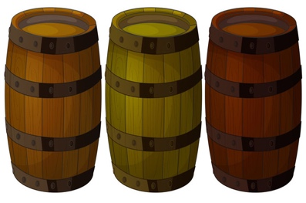
        - – if your own standards are above the threshold of “industry customs,” failing to meet your own standard is not negligent as long as you did meet the general standard of care –
      - Res Ipsa Loquitur – the thing speaks for itself
        - Elements:
          - P’s injury is a sort that normally does not happen absent to negligence
          - D exercised exclusive control over the instruments causing injury
          - P did not contribute to her own injury
        - Why it is needed:
          - It allows P to meet its burden of production and proof
            - You were supposed to behave reasonably, and if you had, I would not have gotten hurt.
          - Does not have to state specifically what D had or not have done, but show that D did not perform their duty of care and caused P harm
    - Causation
      - Cause-in-Fact (Actual Cause)
        - A plaintiff must show, as a matter of historical and physical fact, it is more likely than not D’s conduct was a cause of P’s injury
        - [BUT-FOR] Test –
          - But for D’s conduct, P wouldn’t have been injured
          - [concurrent causes]
        - Multiple Sufficient Causes
          - Restatement – if multiple acts occur, each of which . . . alone would have been a factual cause of the physical harm at the same time in the absence of the other acts, each is regarded as a factual cause of the harm
            - [At the same time] does not mean the acts are concurrent, but that the harm could have manifested at the same time
        - Concerted Action
          - Multiple Ds’ efforts combine to cause P’s injury, it is possible that no one D’s action was sufficient to cause P’s injury and that only when they are combined do they cause P’s injury
            - So long as all Ds engage in tortious conduct in concert with each other – meaning they intend the same tortuous course of action, or one intends to assist the others in engaging in tortious conduct – they are all liable for the harm caused to P
        - Alternative Liability
          - May be the case that only one of the negligent Ds actually caused the injury, but it is very difficult for the P to determine which negligent D caused the harm
            - Where one of the negligent Ds caused the harm, burden shifts to the Ds to avoid liability
              - If neither D can prove they were not responsible, each D is jointly and severally liable – meaning either one can be held responsible for the entire injury
      - Superseding Cause
        - Some other thing some other person did may break the chain of causation
      - Proximate (Legal) Cause
        - Legal doctrine to limit D’s liability when the chain of causation becomes too remote, attenuated, or unforeseeable
    - Harm
      - Damages
    - Defenses to Negligence
    - NOTES
      - Branch of tort law where accidental harm is studied
        - If you injure someone and can legitimately say, “oops, sorry, my bad,” most likely talking about negligence

